Final Expansion 3 User Guide
Version 1.0

Copyright Information
This work is licensed under a Creative Commons Attribution-ShareAlike 4.0 International License, see http://creativecommons.org/licenses/by-sa/4.0/
Any trademarks mentioned are the property of their owners.

Version Information
Version | Date | Changes
1.0 | 2017-02-08 | Initial draft

Authors
Simon Rowe <srowe@mose.org.uk>
Contents
Copyright Information 2
Version Information 2
Authors 2
Introduction 4
Where to Get Help 4
Cartridge Overview 5
Start Up Menus 7
RAM Manager 7
Wedge Commands 10
Storage Device Commands 10
Load BASIC Program 10
Load Machine Code Program 10
Save BASIC or Machine Code Program 11
Verify BASIC Program 12
Show & Change Drive 12

Introduction
This guide describes the features of the Final Expansion 3 cartridge for the VIC-20 and how to use them. It also includes reference material for programmers to write software that uses the advanced capabilities of the cartridge.
The information given in this guide is believed to be accurate, however because there are many hardware and software variations the authors cannot guarantee that a specific system will function exactly as described.
The authors would be grateful to hear from you if you find a mistake or omission in this guide.

Where to Get Help
As there are several versions of the cartridge produced by different manufacturers the best source of information specific to yours is wherever you purchased it from.
The on-line forum Denial, http://sleepingelephant.com/ipw-web/bulletin/bb/index.php, is a community of VIC-20 users. They may be able to provide information and suggestions but cannot be expected to resolve your problems.

Cartridge Overview
The Final Expansion 3 (FE3) cartridge expands the VIC-20 with:
- 512KB of Random Access Memory (RAM)
- 512KB of Electrically Erasable Read Only Memory (EEPROM)
- storage to Secure Digital cards emulating a disk drive (SD2IEC)
The memory expansion is highly configurable, both from an interactive menu and by commands contained in user-created files. Virtually any type of memory map can be set up to allow all manner of programs to be run.
Additional commands are available to make disk devices easier to use, these are provided using a software wedge (which can be disabled) similar to those supplied with physical disk drives such as the 1541.
Loading and saving to IEC bus devices is accelerated if they contain support for JiffyDOS, this includes the integrated SD2IEC device.
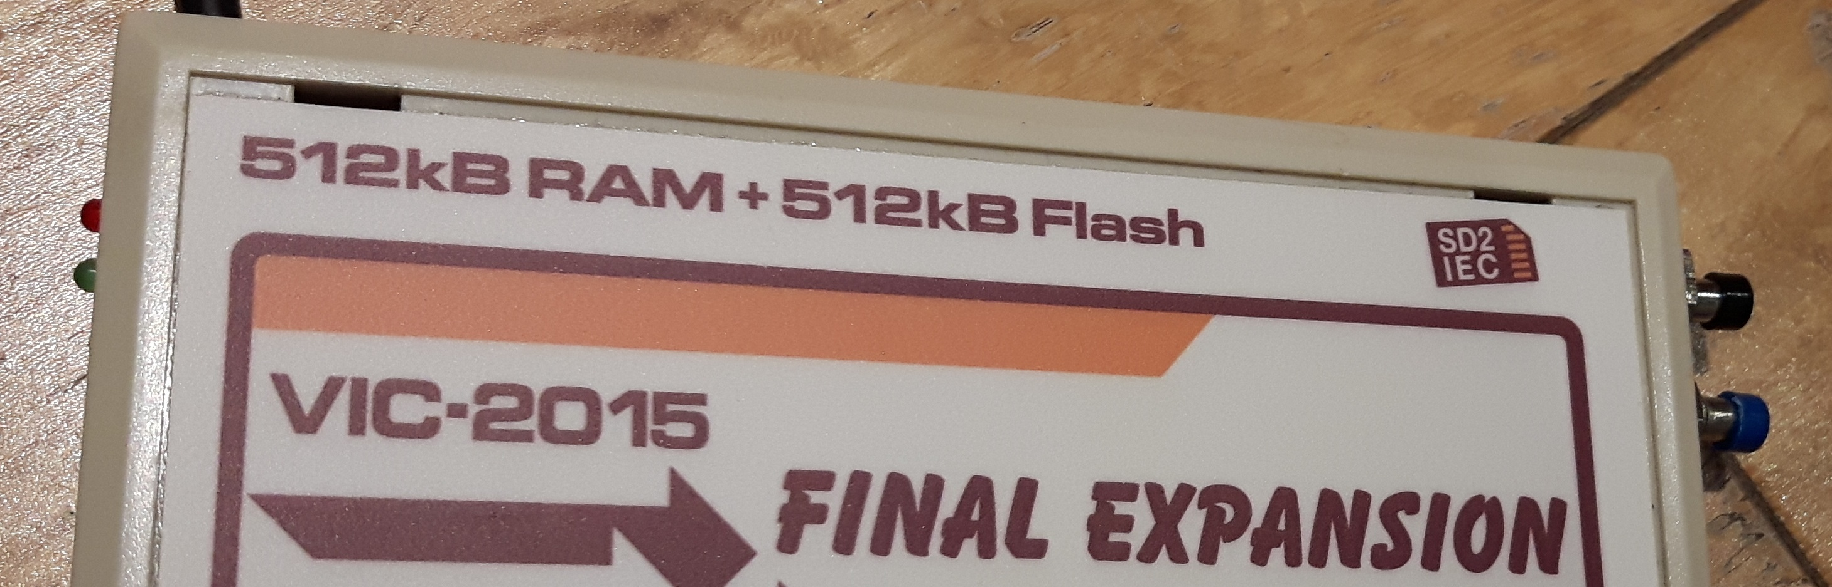
The two indicators which are located on the left of the cartridge relate to the SD2IEC device
- error (top, red) – flashes when an error message is present on the command channel
- activity (bottom, green) – lit when a file is open on the device
The two push buttons on the right of the cartridge provide different forms of system reset
- VIC-20 system reset (top)
- VIC-20 and Final Expansion 3 reset (bottom)

Start Up Menus
When the VIC-20 is powered on the following menu is presented. Options are selected by pressing the function keys (along with the Shift key if necessary).

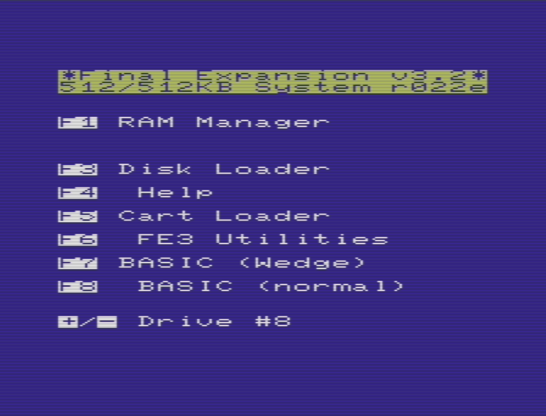
RAM Manager
This submenu allows different memory configurations to be set up
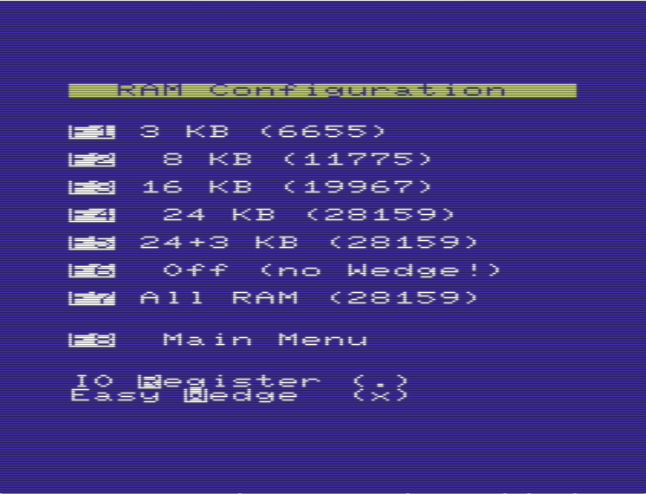
The configurations are summarized in the following table:
Key | Memory | Blocks | Wedge?
F1 | 3K | RAM1,2,3 | Yes
F2 | 8K | BLK1 | Yes
F3 | 16K | BLK1,2 | Yes
F4 | 24K | BLK1,2,3 | Yes
F5 | 24K+3K | RAM1,2,3 & BLK1,2,3 | Yes
F6 | - | - | No
F7 | 24K+3K+8K | RAM1,2,3 & BLK1,2,3,5 | Yes
At the bottom of the menu two checkboxes are shown:
- I/O registers (R) - Allow access to the registers which control the memory configuration of the cartridge
- Command wedge (W) – Enable commands listed on page 10
Pressing the given key toggles each checkbox.
“F8” returns to the main menu.

Wedge Commands
The following commands are available in immediate mode, they cannot be included in BASIC programs.
File names may be given in quotes or follow the command immediately (unless otherwise stated).

Storage Device Commands

Load BASIC Program
The ‘/’ command can be used to load a program from the current device
/SNAKE
FROM $0401 TO $0F8B
RUN
The start and end addresses are displayed in hex.

Load Machine Code Program
The ‘%’ command can be used to load a machine code program into the correct location in memory
%MEMSOAK
FROM $0400 TO $0A0B
SYS1024
The start and end addresses are displayed in hex, the start address is often used to execute the program.

Save BASIC or Machine Code Program
The ‘←’ command can be used to save the program in memory to the current device
HELLO
FROM $1201 TO $1234
The start and end addresses are displayed in hex.
To save a machine code program the file name must be given in quotes followed by the start and end addresses
GRAPHICS,$2000,$300
0
FROM $2000 TO $3000
If the file already exists on the device the following prompt is displayed
63,FILE EXISTS,00,00

BORT EPLACE PDATE
Pressing ‘R’ deletes the existing file and saves the current program with the file name given.
DELETING FILE ...
Pressing ‘U’ renames the existing file with “′” (single quote) character at the beginning then saves the current program with the file name given.
DELETING OLD FILE ...
RENAMING FILE ...
Pressing ‘A’ cancels the operation.

Verify BASIC Program
The ‘>’ command can be used to verify that the program in memory matches the copy saved to the current device
>CATACOMBS
FROM $0401 TO $12E4

OK

Show & Change Drive
The ‘#’ command can be used to display the current device number
#
DEVICE#8
To change to another device a number between 8 and 15 may be appended
#9
DEVICE#9

